Qn: How to stop someone to inherit your class ?

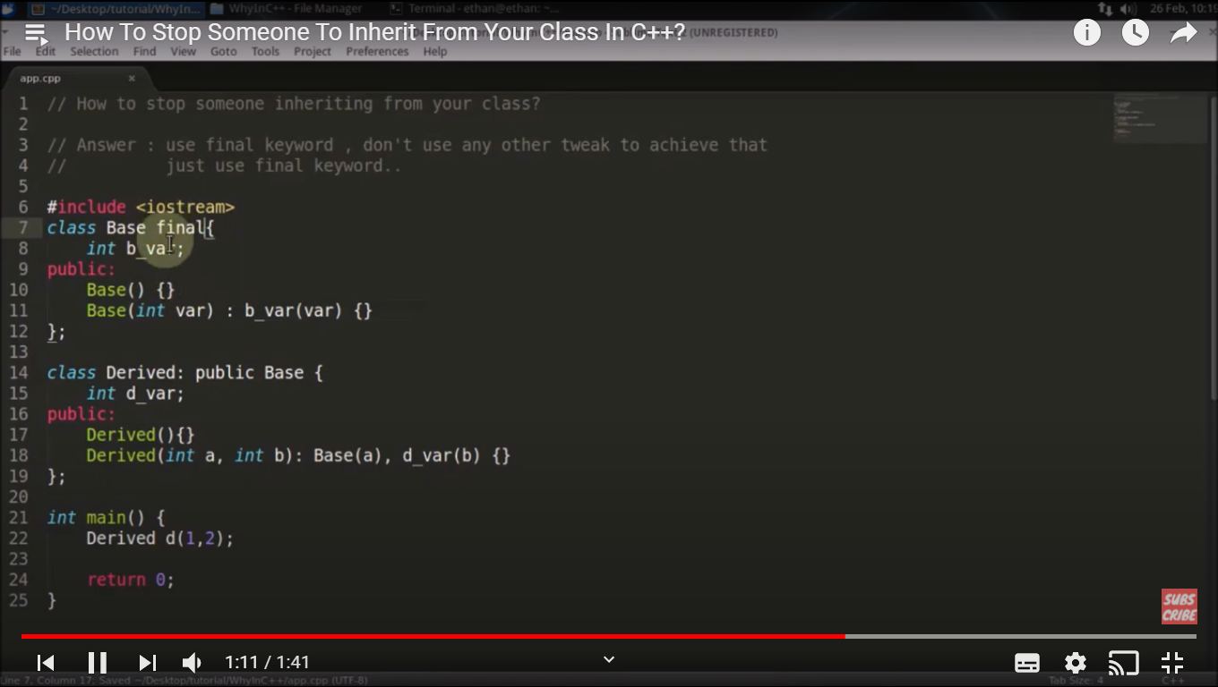

Qn: How to check two different objects belong to the same class ?

Use typeid.

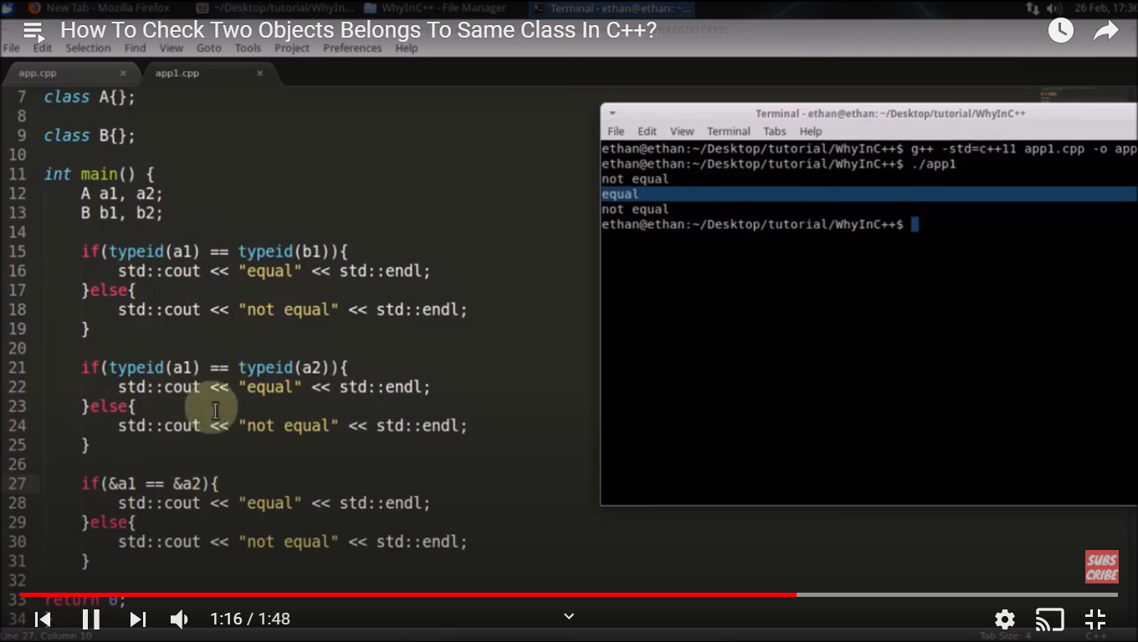

Qn: How to print something N number of times without using any loop or recursion ?

Using constructor and array.

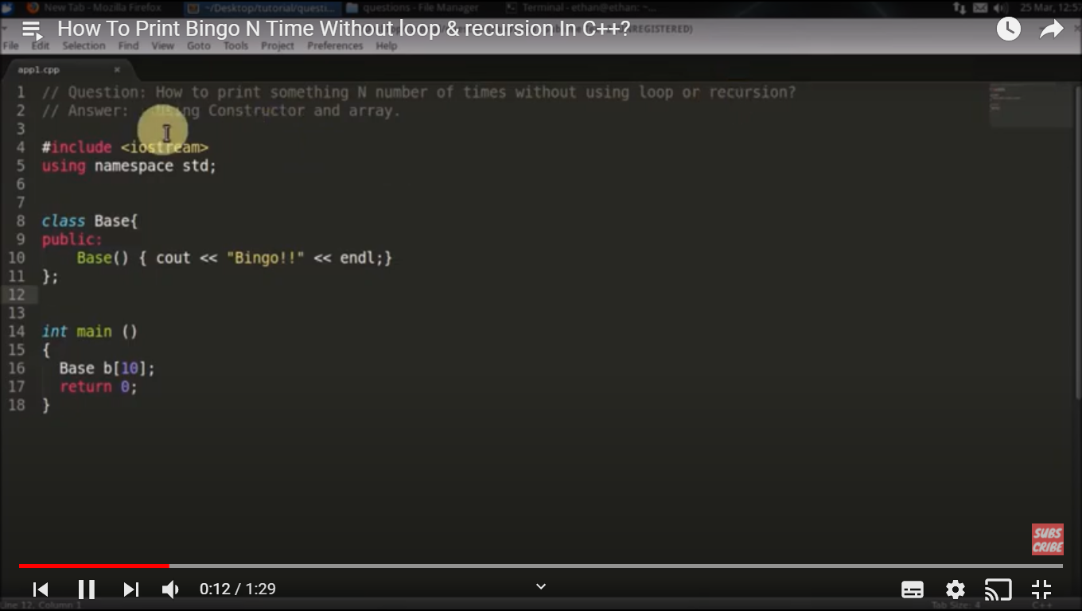

Qn : What is the difference between struct and class in C++ ?

1. Struct has default public members but class has default private members.
2. If we inherit from class by any access specifier by default it is inheritted as private but in the same case by default is is public in struct.

Qn: How to overload pre and post increment operator ?

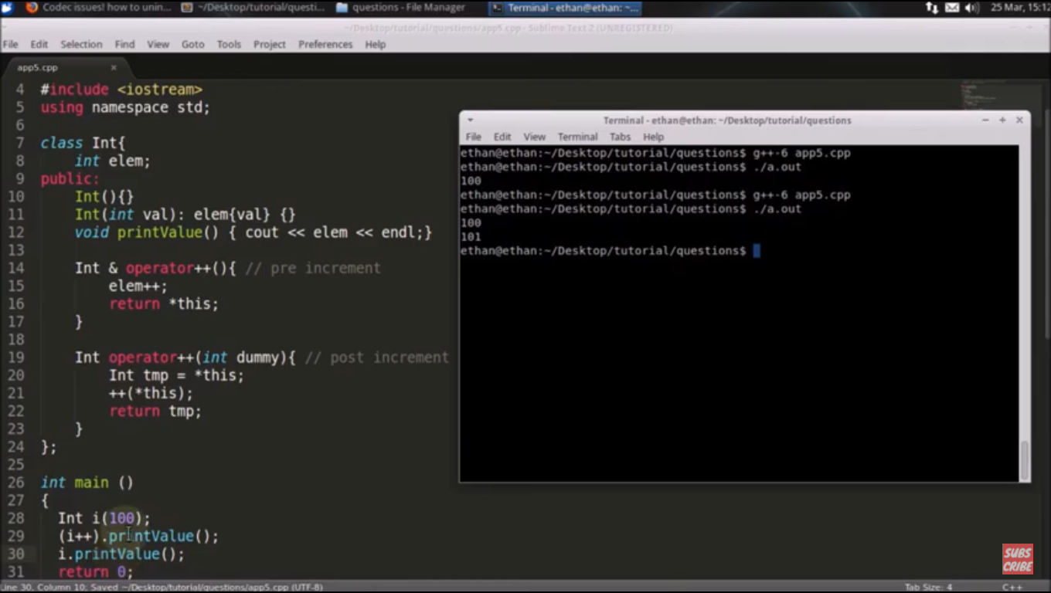

Qn: Why we must define static member of a class in .cpp file not in header file.

Because heade file is included ain many files and at whole it would through multi definition error.

Qn : Which is faster post increment or pre increment ?

Pre increment is faster that post increment, it can be proved by analysing .s files generated during compile time.

Qn : What is function chaining in C++ ?

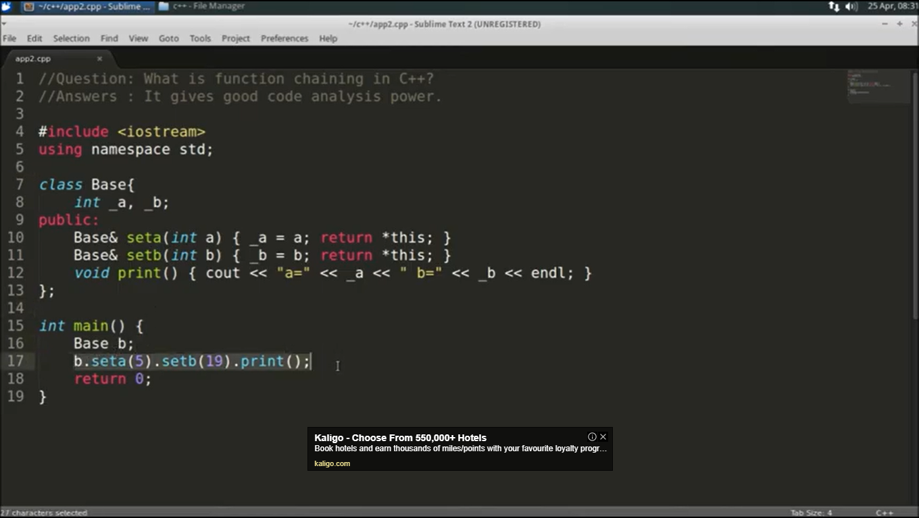

Qn: How static variable behaves in template functions.

Each static variable is coupled with different templated type function definition.

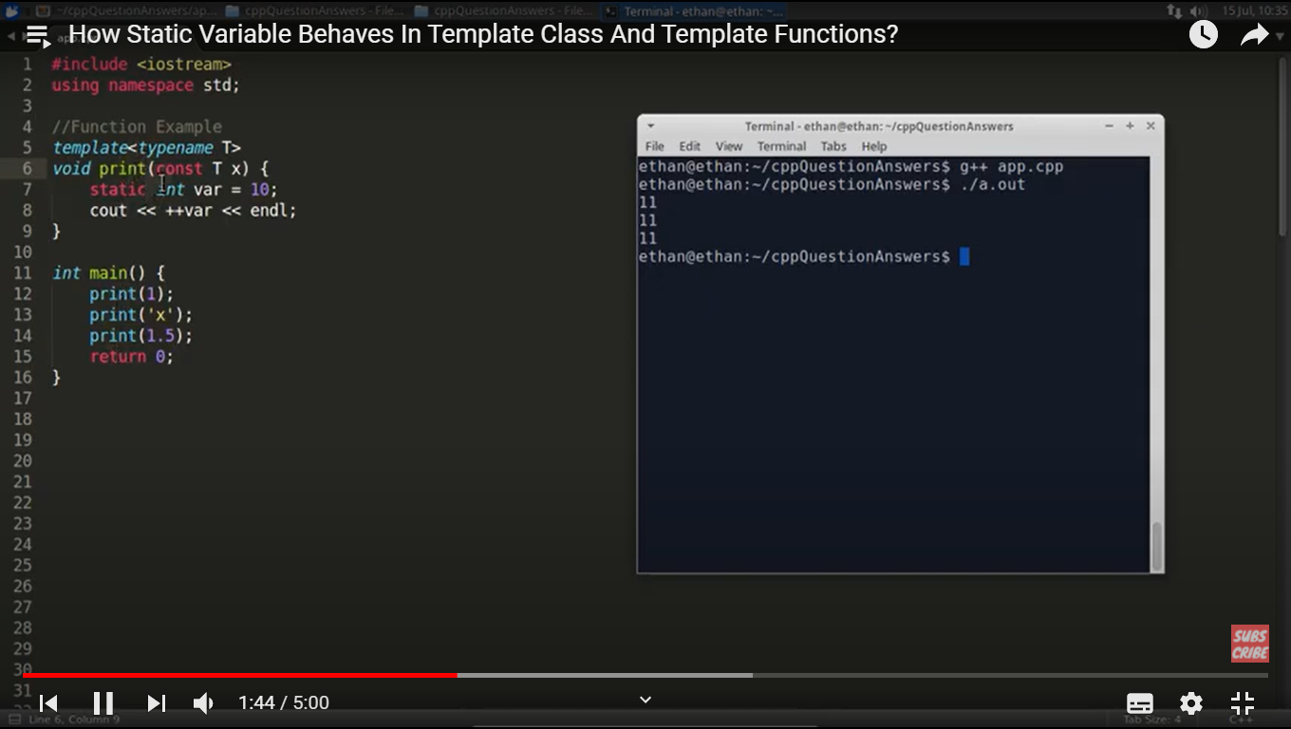

Qn: How to stop copying your object ?

Method – 1 : Keep copy constructor and assignment operator as private in class.

Method – 2 : Inherit dummy class with private copy constructor and assignment operator.

Method-3 : Delete copy constructor and assignment operator from your class.

A(const A &obj) = delete;

A& operator = (const A&obj) = delete;

Qn: How to stop someone to take address of your object ?

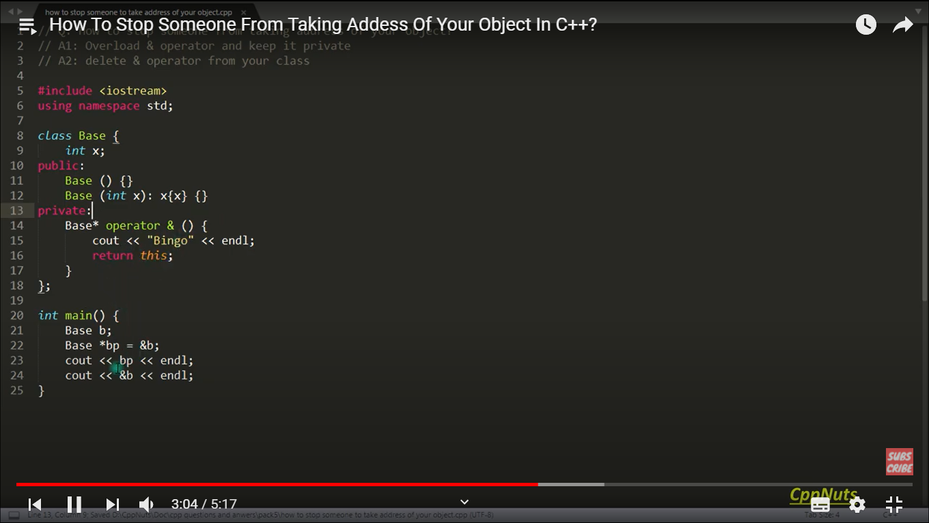

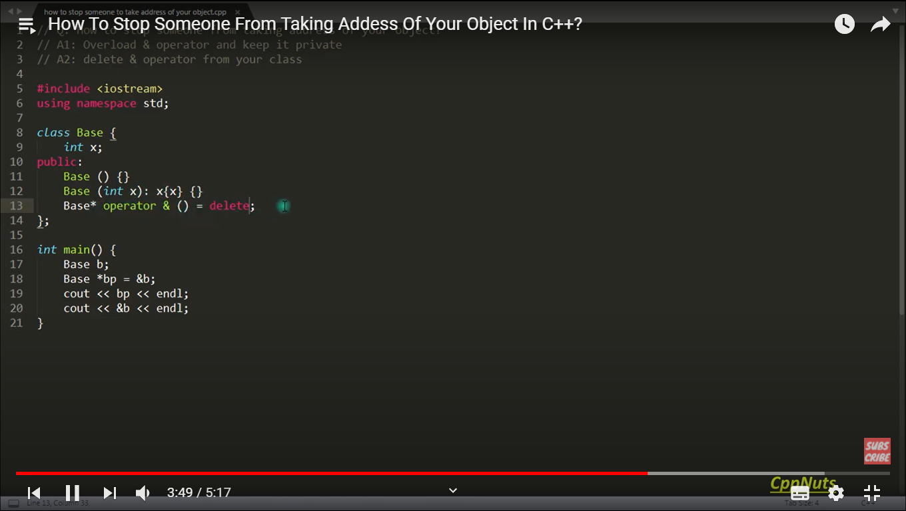

Qn: How to write your own atoi function ? (ascii to integer)

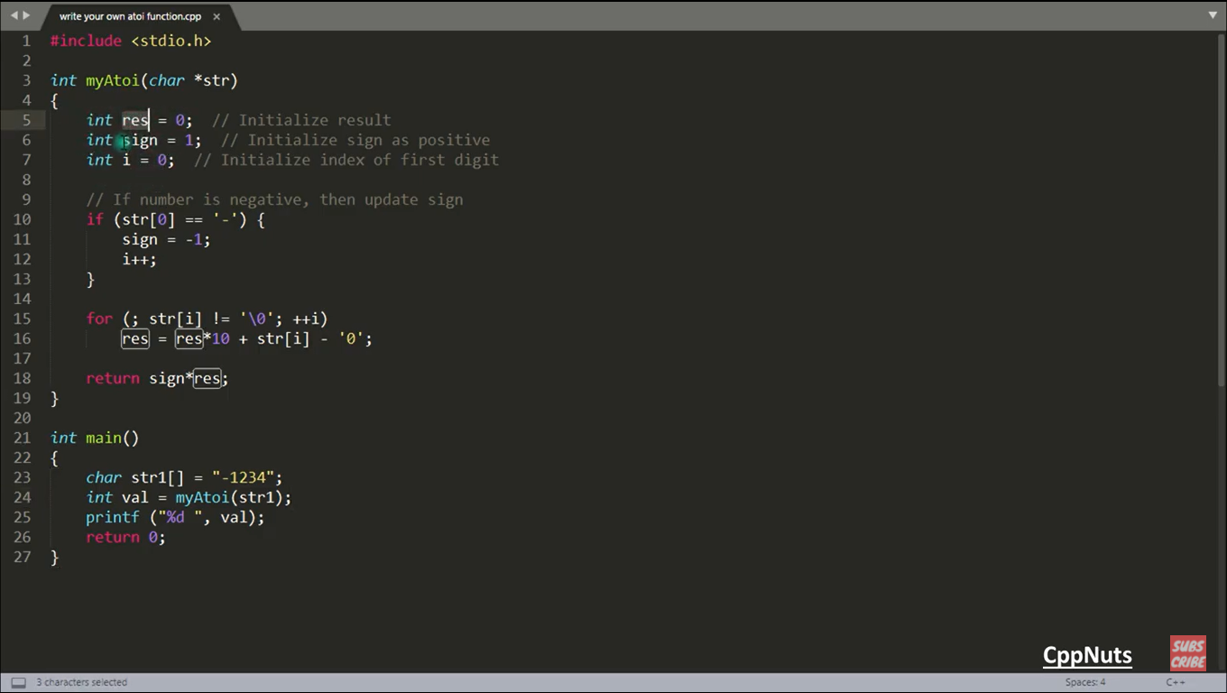

Qn: What is function hiding in c++ ?

The below snipped will print “derived” in both the calls:

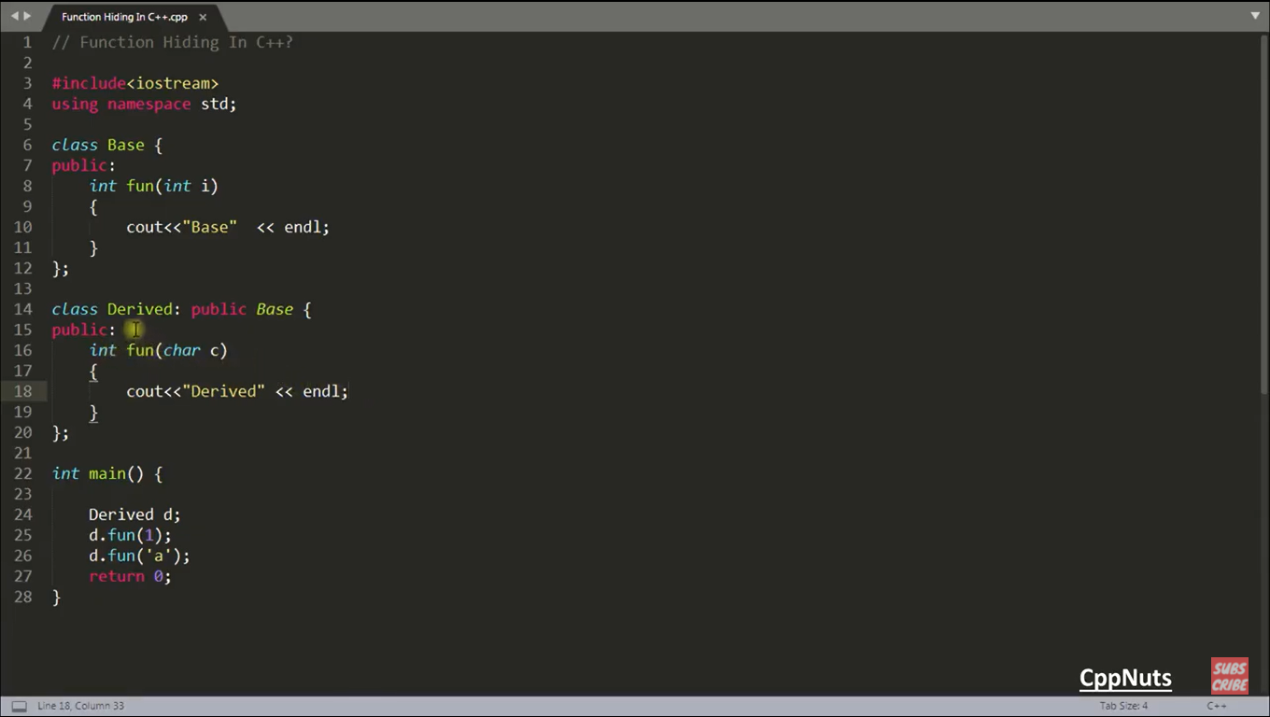

Solution:

First solution:

d.Base::fun(1);

Second solution:

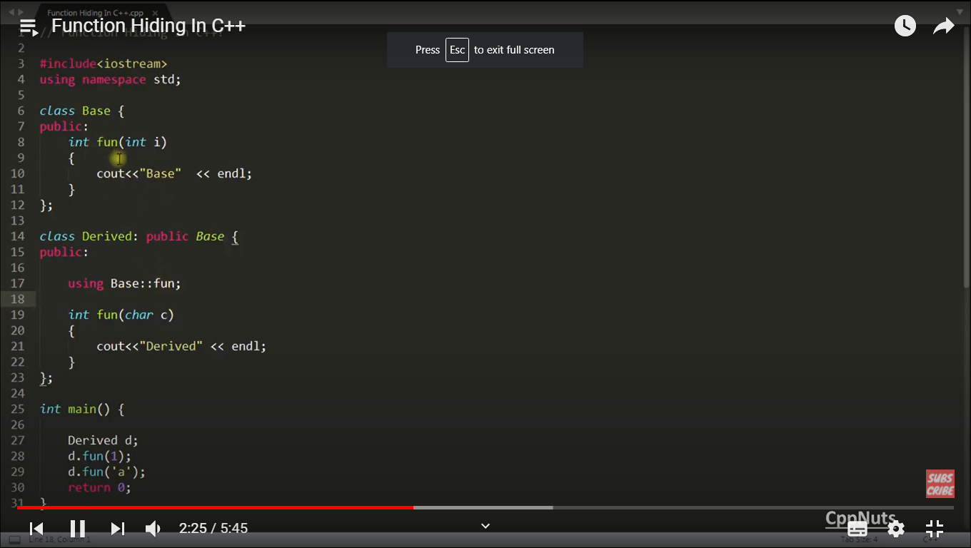

Qn : What is difference between operator [] and at() function in accessing a vector ?

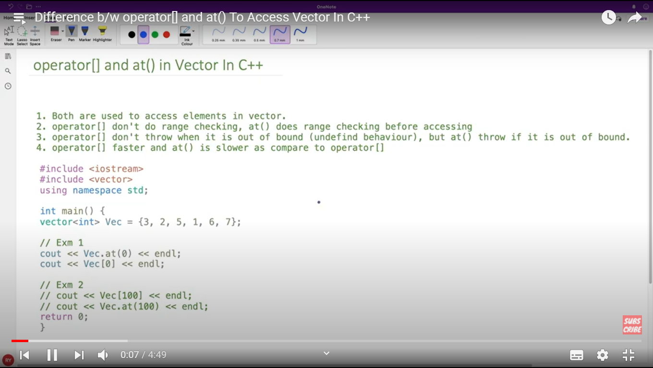

Qn : How to make a class non inheritable without using final keyword ?

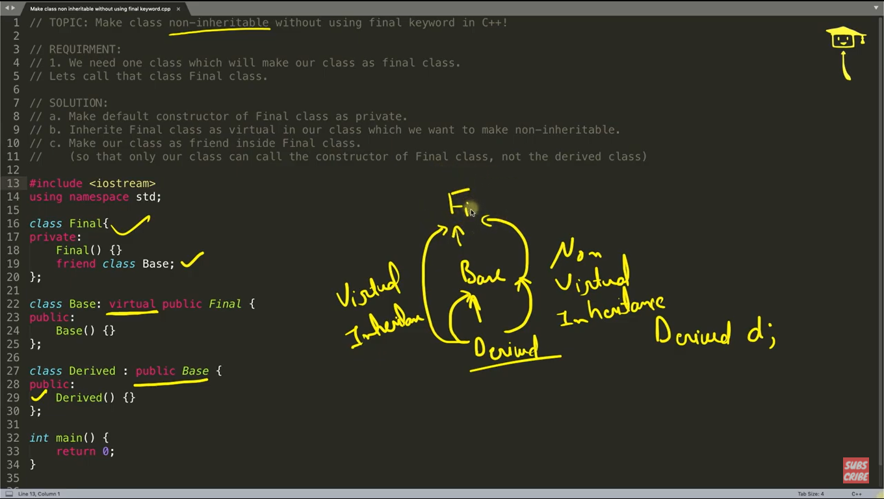

Qn: What is difference between association, aggregation and composition ?

Association : By value.

Aggregation : By reference.

Composition : Object is constructed inside the class.

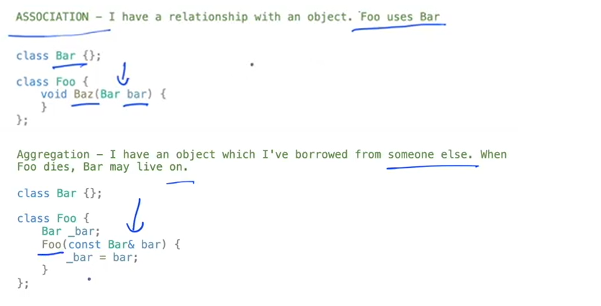

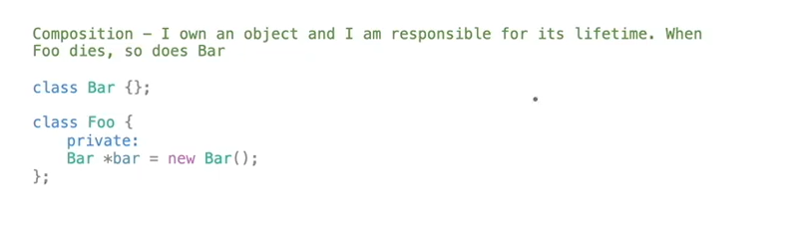

Qn: What is adapter design pattern ?

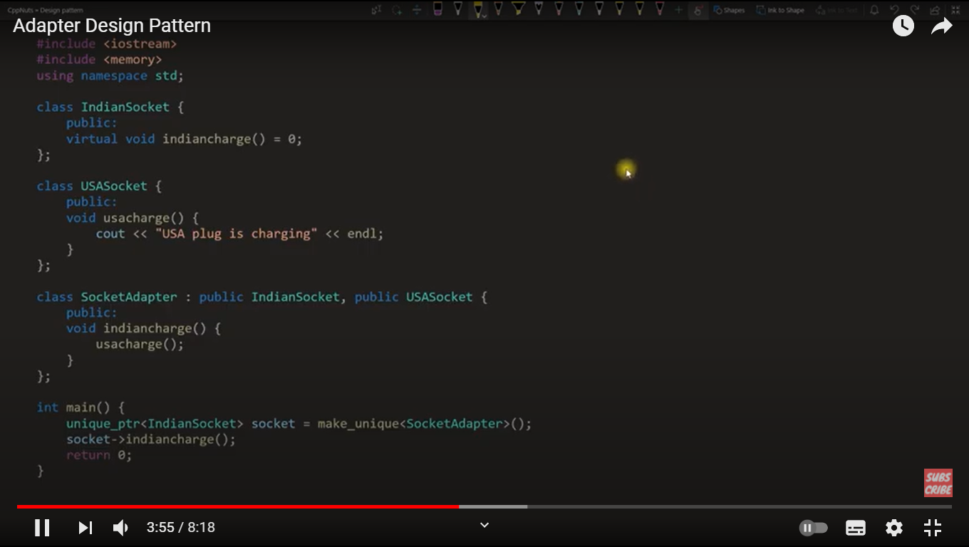

Qn : How to make member function of one class as friend of another class ?

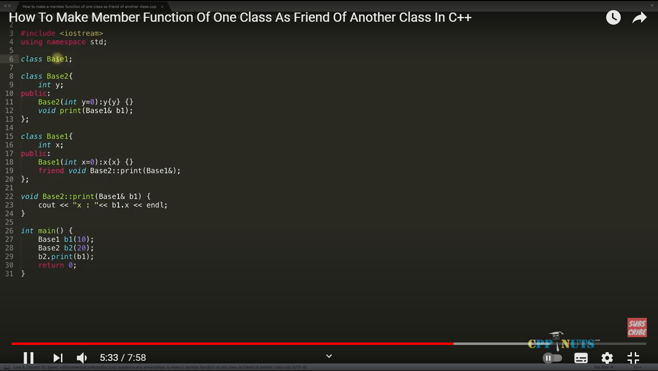

Qn: How to check for BIG Endian and Little Endian ?

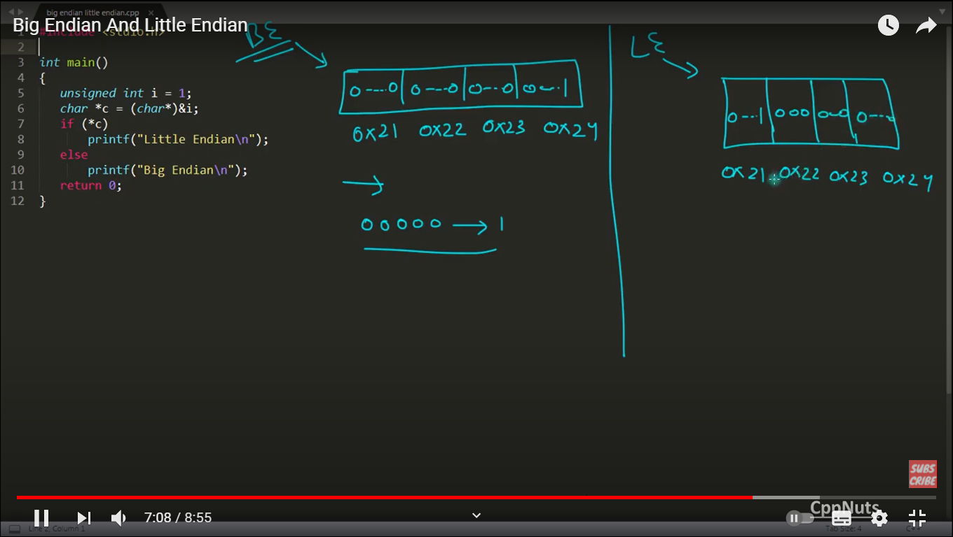

Qn : How to print something without semicolon ?

int main() {

If(printf(“nikhil”)){}

Return 0;

}

Qn : What is diamond problem in C++ ?

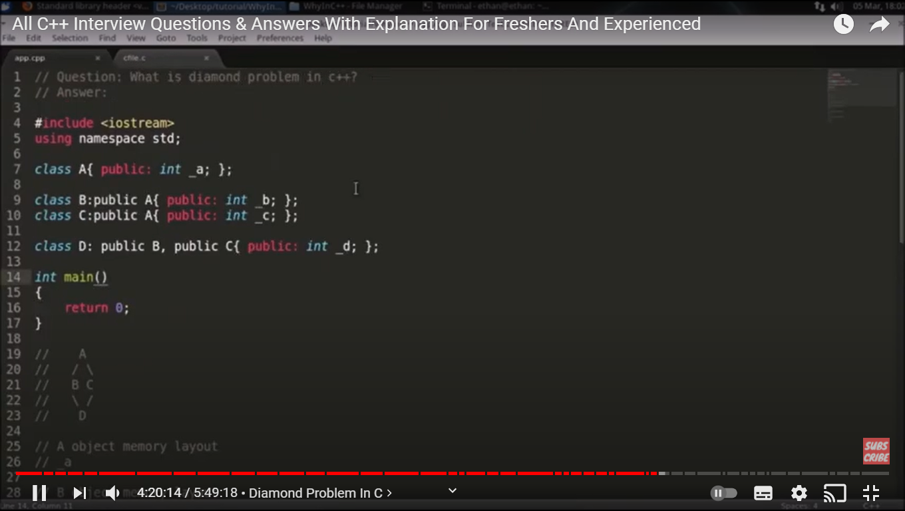

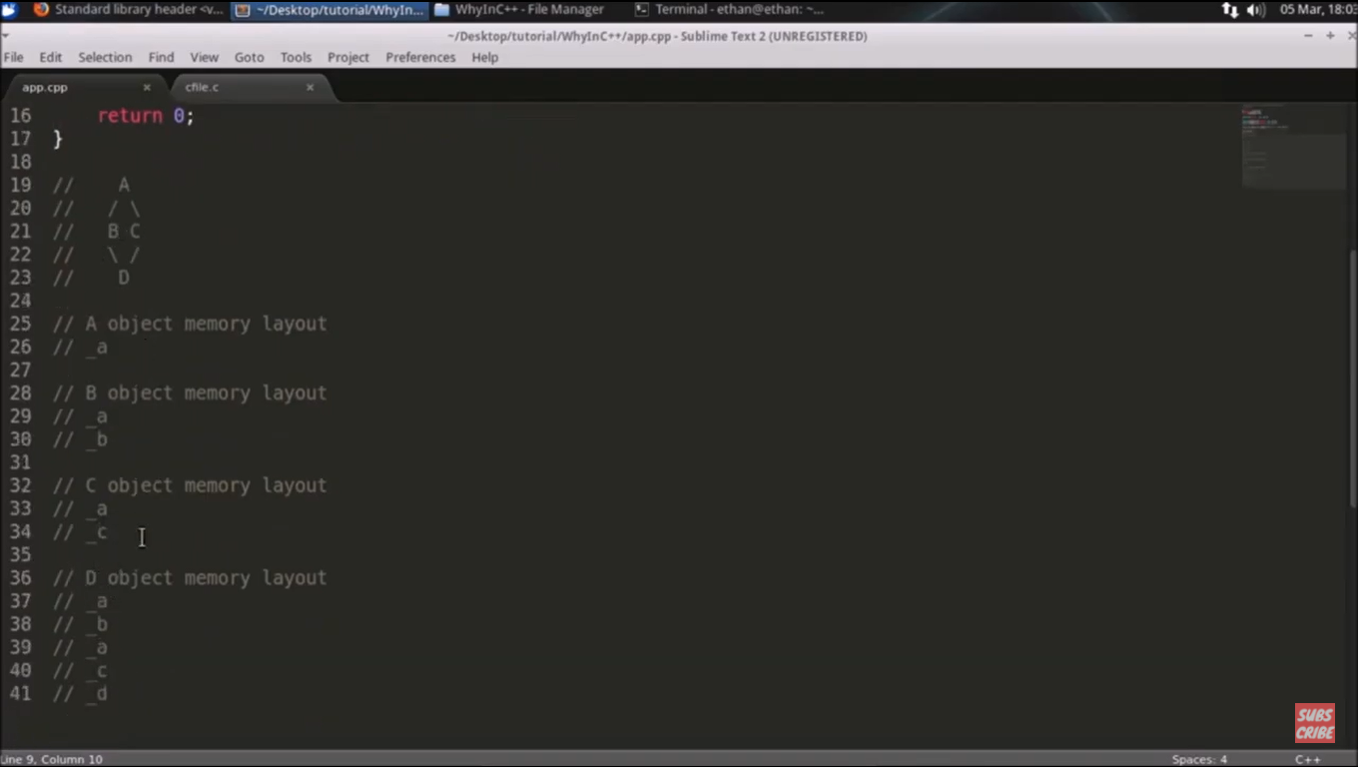

Solution:

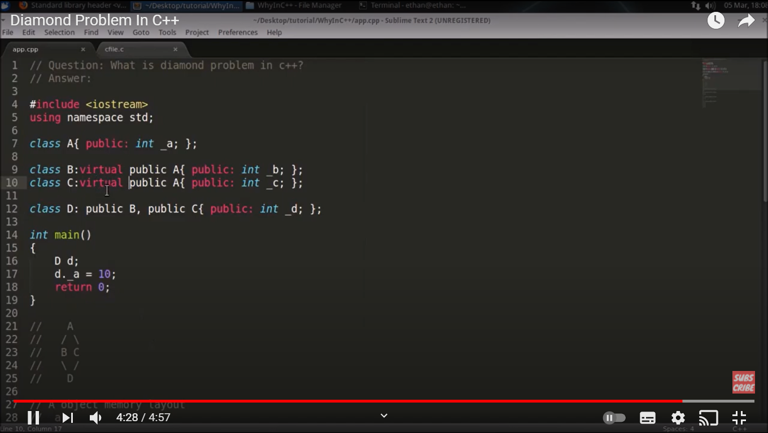

SMART POINTER

=====================================================================================

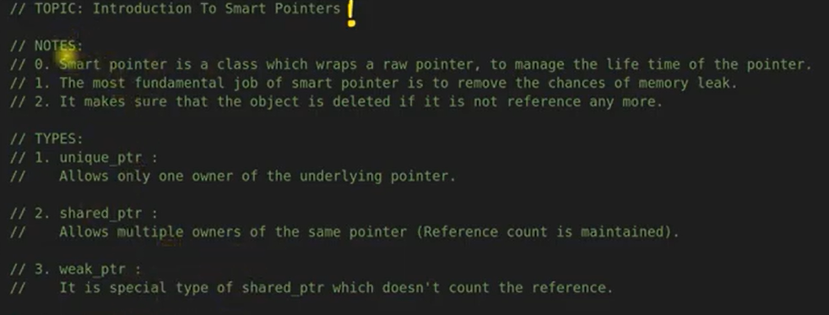

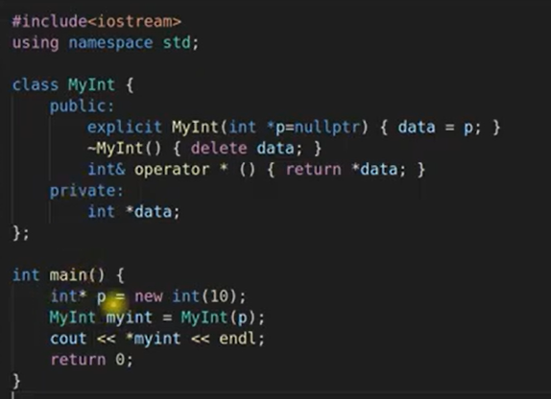

Unique Pointer:

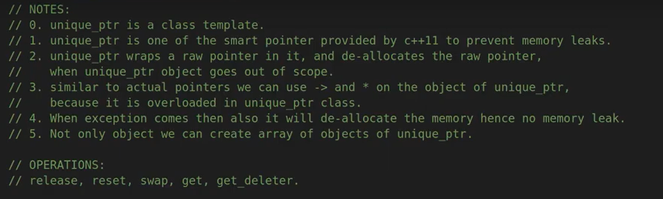

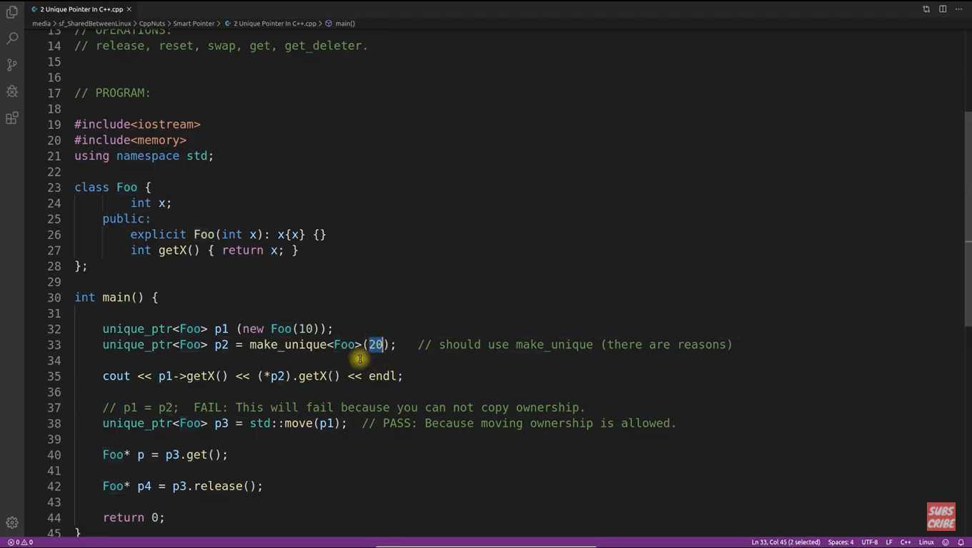

Copying ownership is not allowed because, ownership should be unique. Only one unique_ptr will have ownership to delete and own a raw pointer.

Moving the ownership is allowed. After moving ownership, old unique_ptr will become to pinting nullptr.

Release() functions releases ownership and becomes nullptr. It releases ownership to delete to the raw pointer itself.

P2.reset(p4); -> it changes underlying raw pointer object.

Shared Pointer:

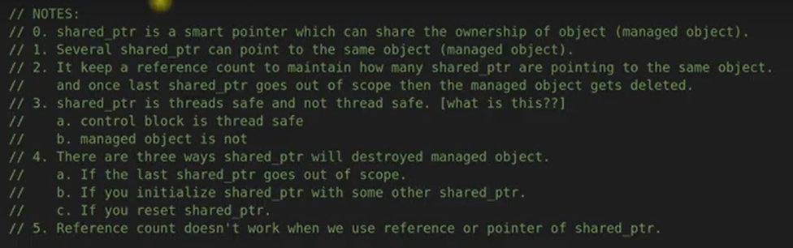

Note: Refernce count doesn’t increase if we pass shared_ptr as reference or we pass address of a shared pointer to a pointer of shared_ptr. Reference count only increases if shared_ptr is copied as value not by reference or pointer.



CB(control Block) : It stores the reference count and it is thread safe.

MB(Memory Block) : It stores managed object, it’s not thread safe. We need to use mutex to make it thread safe.

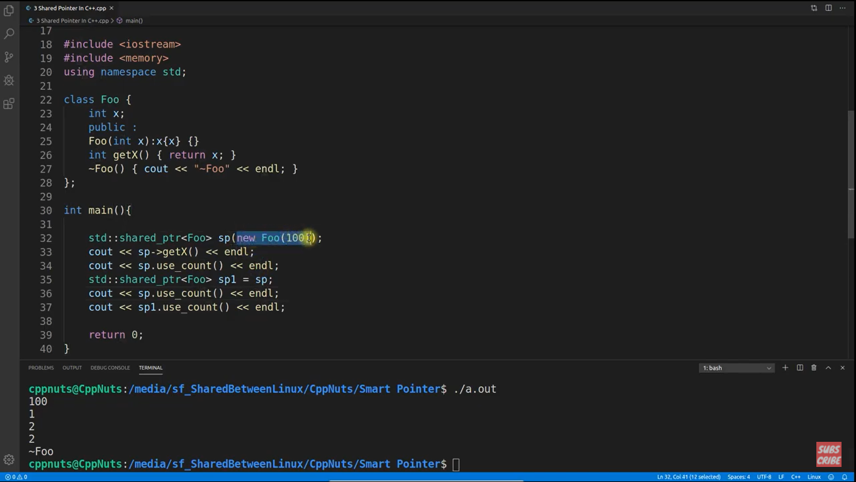

Std::shared_ptr<Foo> &sp2 = sp; // it wont increment reference count.

Std::shared_ptr<Foo> *sp3 = &sp; // it wont increment reference count.

CB holds reference count. Below thread program is example of CB is thread safe.

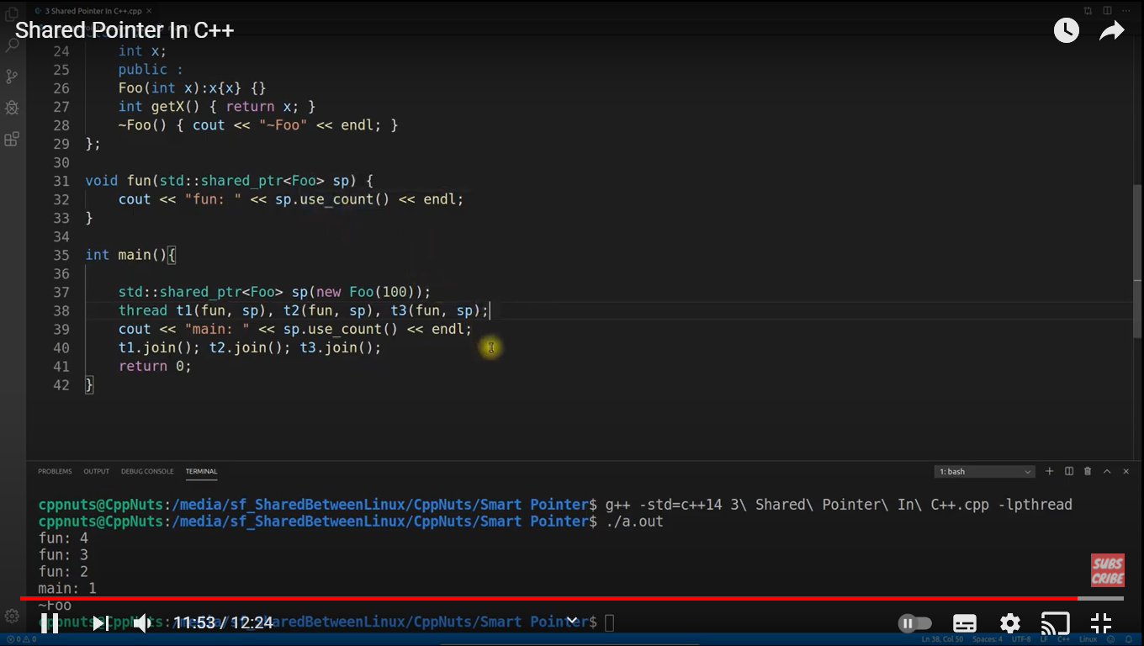

Note: Destructor is always called one time when last shared pointer goes out of scope.

WEAK POINTER:

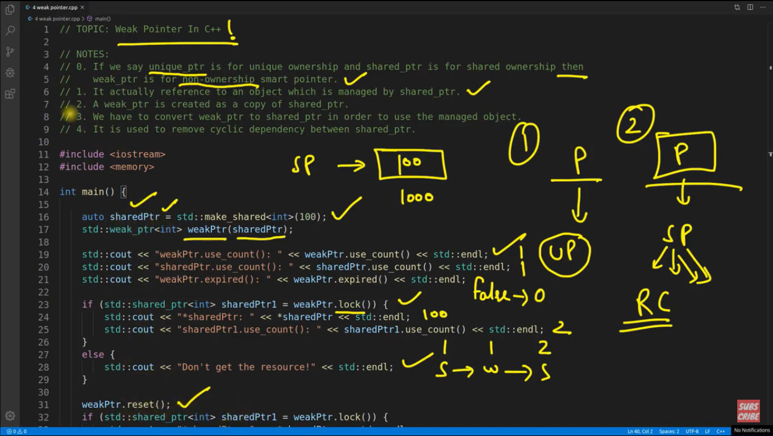

We can’t dereference a weak pointer. In order to dereference we need to get a shared pointer created with help of wek pointer object. It will increase a ref count because of copy.

Lock() function provides the underlying shared pointer of weak pointer.

Reset() function releases the resource (underlying sharedpointer ).

Once underlying shared pointer object goes away because of ref count becomes 0 then weak pointer expired() function results true.

We can remove cyclic dependency between two shared pointer by making one as weak pointer instead of shared pointer.

**L- VALUE AND R-VALUE:**

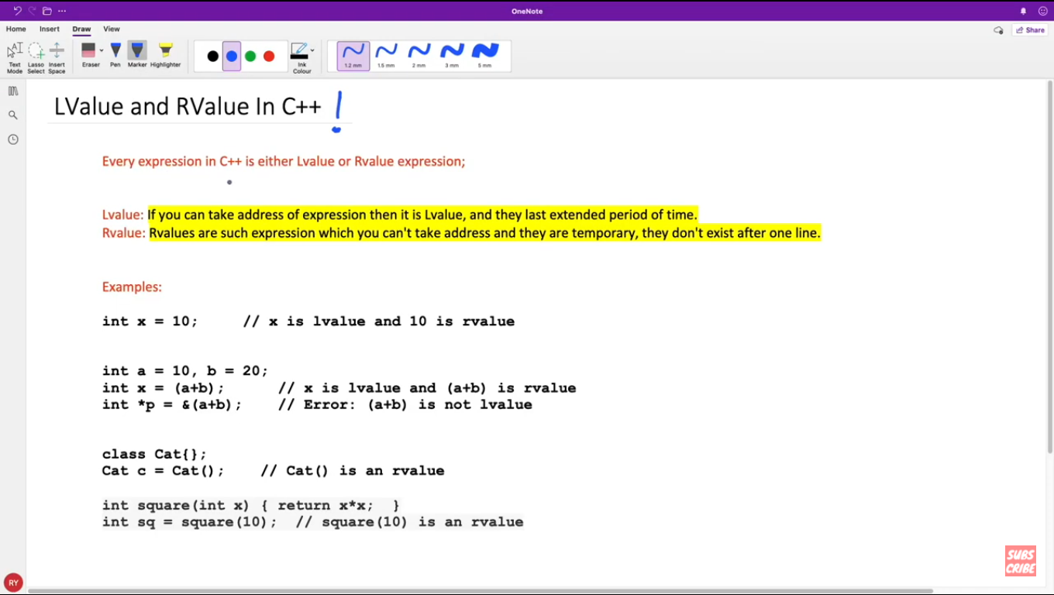

Note: You can wind rvalue with lvalue reference using const.

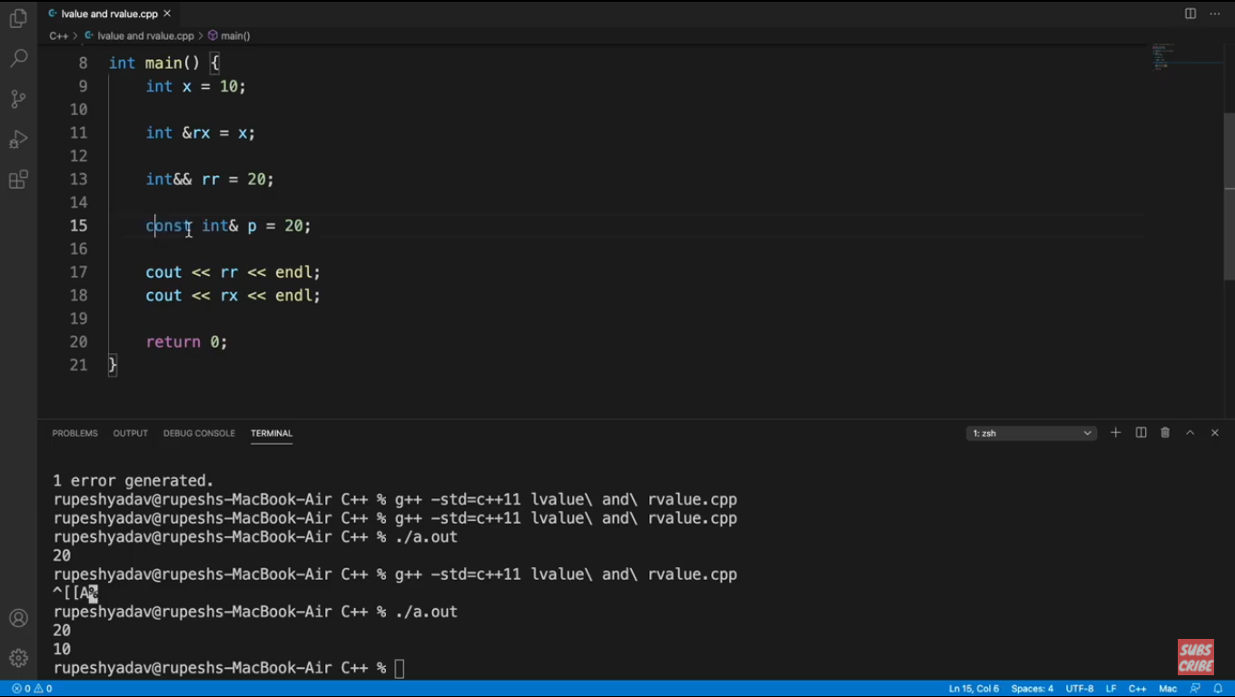

Note: rx is lvalue reference and rr is rvalue reference.

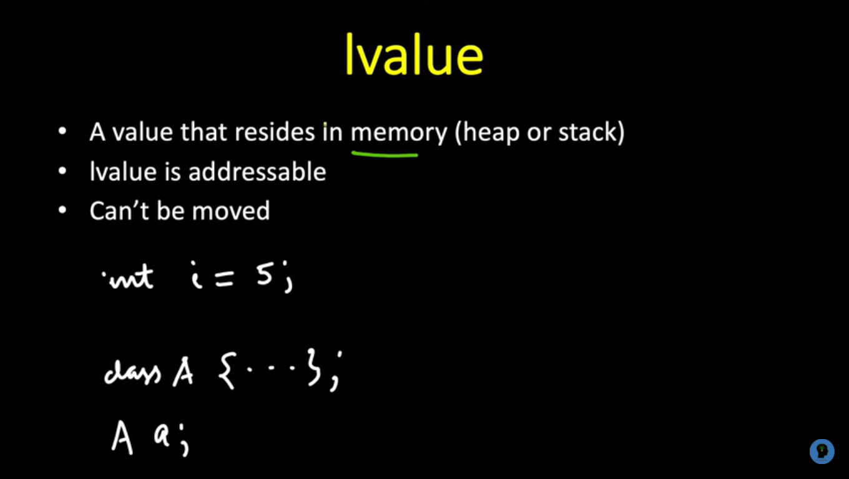

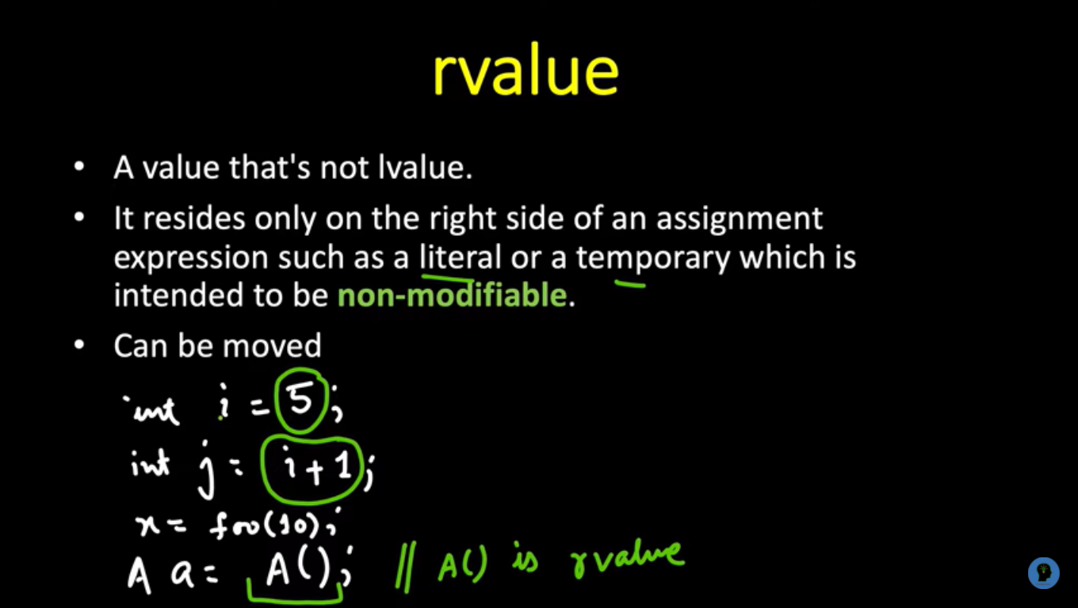

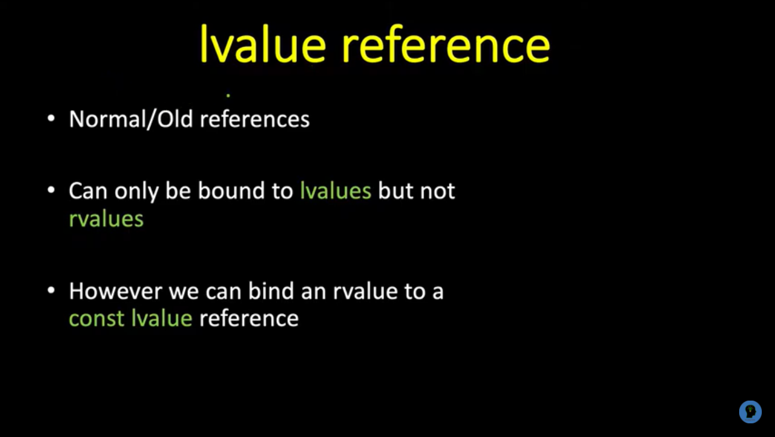

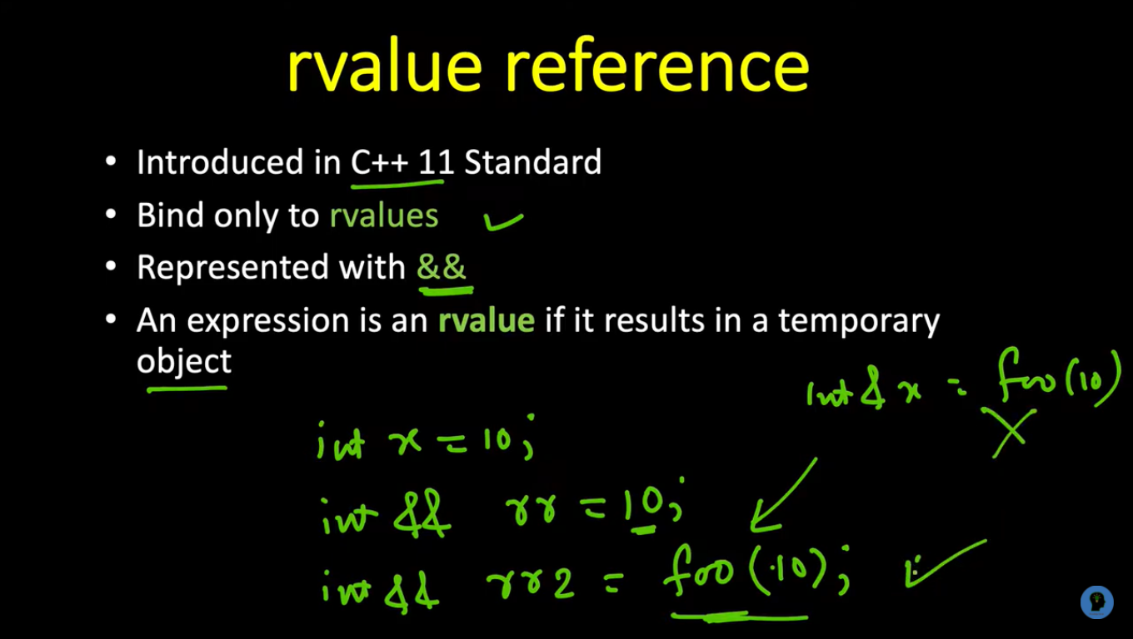

Note: std::move() converts lvalue to rvalue.

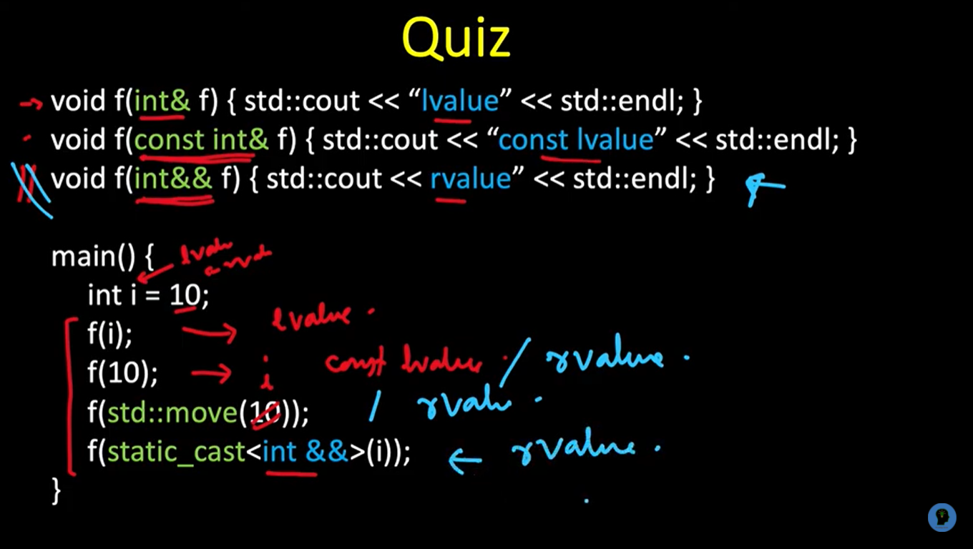

**MOVE SYMANTIC IN C++ :**

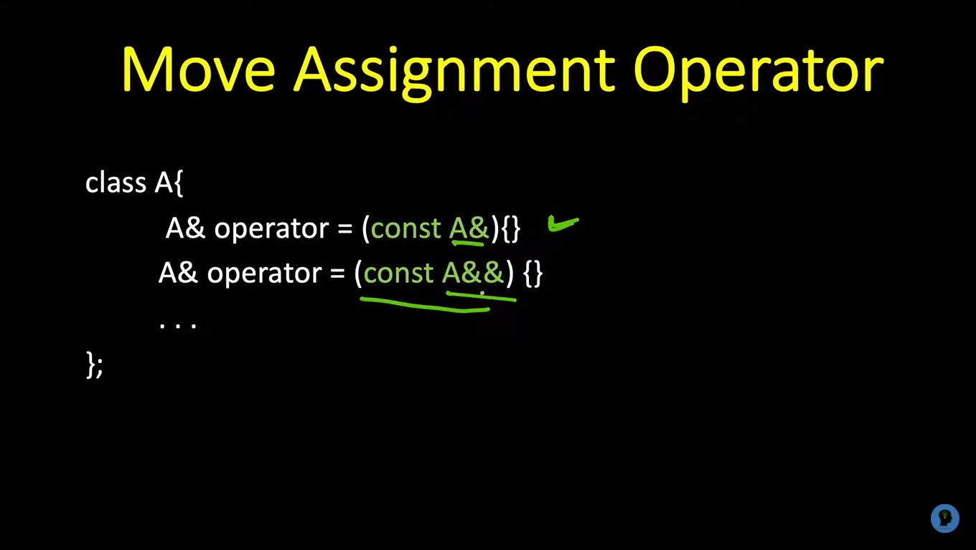

A a;

A b;

a = b; // calls lvalue copy assignment

a = std::move(b); // calls rvalue copy assignment

a = std::move(A()); // calls rvalue copy assignment.

Rvalue is useful for calling these functions using temporary object. This is the benefit.

Std::move() is used to cconvert lvalue to rvalue.

**COMPIL OPTIONS:**

-c [create object file]

g++ -c nik.cpp // creates nik.o

-E [generates preprocessed file]

gcc -E file.c > <preprocessed_file.txt>

-S [generates assembly code]

g++ -S nik.cpp // generates nik.s assembly code // used to check tail call optimization

-O1, -O2, -O3 [ different level optimization]

-g [enable to generate debug symbols for debugger gdb]

-wall [generates all warning]

-werror [generates warning as error]

-w [inhibits warning]

gcc nik.c -save-temps // generates all files: .ii, .o and .s

**Whats is emplace in C++ ?**

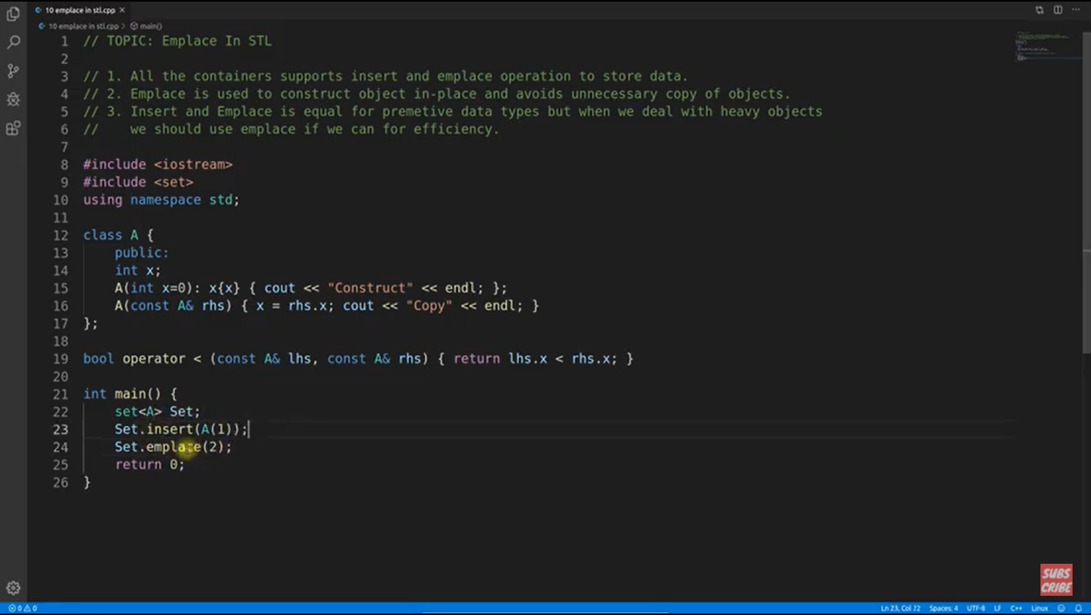

Set.insert(A(1)) : It will construct and copy

Set.emplace(2) : It will only construct no copy so it is faster.

**Constness With pointer : Easy To Remember:**

